Dear Colleague,
On 2-23-2015, Dr. Steven Weinberger, the President of ACP, sent a disturbing letter (attached) critical of NBPAS to its members. Below, NBPAS addresses each point made by ACP:

- ABIM has reached out to ACP for assistance in recruiting a sample of physicians in clinical practice who can provide input about the blueprint that ABIM uses for selecting topics for questions on the secure examination. “The feedback that ABIM would like to get about each topic concerns ‘how frequently is the topic seen in practice’ and ‘how important is it for a practitioner to know about this topic’.”
National Board of Physicians and Surgeons  Tel (888) 861-4448 Fax (888) 861-4449  info@nbpas.org  www.nbpas.org | 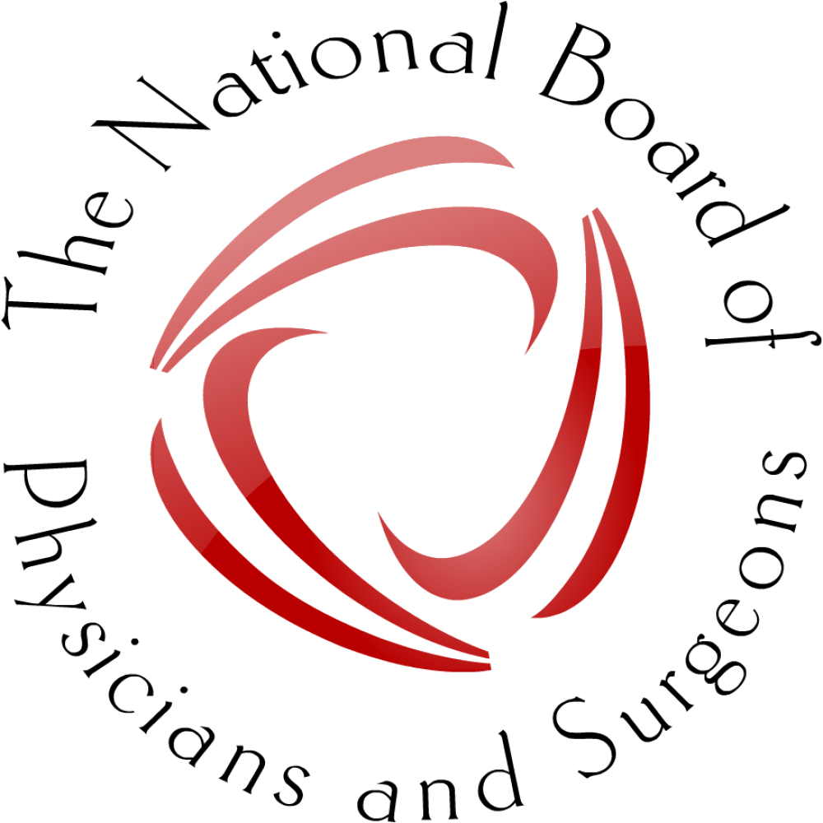

ACP misses the point. Clinical practices within a specialty vary greatly. Practice knowledge modules and secure exams are not tailored to individual practices and therefore will always be irrelevant to a large proportion of certifying candidates.

- Will an alternative pathway be credible to substitute as a credentialing requirement for hospitals and health plans?
Many hospitals are currently considering such a substitution. Many believe a substitution will be credible and is sorely needed. Additionally, it should be noted that in some areas, NBPAS requirements for certification are more stringent than ABMS requirements (i.e. the NBPAS requirement for active hospital privileges in some specialties and the NBPAS requirement for privileges in the certified specialty to never have been involuntarily revoked and not reinstated).
- If you are named in a medical liability lawsuit, how will it appear when it is noted that you have not recertified through ABIM but have instead tried to show that you are “certified” through a process that has not been widely accepted and whose requirements are minimal?
NBPAS is surprised ACP would resort to such scare tactic. This is simply an embarrassment. Does ACP think physicians are naïve enough to believe ABIM certification will impact lawsuits? NBPAS Board members are thought leaders in the medical community. Clearly, NBPAS certification carries gravitas.
- If you have a time-limited certificate from ABIM, are you willing to forfeit that primary certification in internal medicine and/or a subspecialty of internal medicine when that certificate expires?
This is another misguided embarrassing scare tactic. ACP leadership is attempting to mislead candidates about the ABIM MOC process. If one does not initially pursue MOC and later decides to pursue MOC, all one has to do is make up the deficiencies, and, of course, pay ABIM’s fees.
- Is the fee for an alternative pathway reasonable considering both what you are getting as well as the expenses of the group that has developed the alternative pathway? For example, a fee of $169 every 2 years is almost half of the ABIM’s internal medicine MOC fee, but the alternative organization has no program or product development costs, as all it is doing is sending an electronic certificate (there is an additional charge for a paper certificate).
NBPAS (a 501 (C) (3) organization. Fees will be adjusted (hopefully down), to cover expenses. NBPAS is a grassroots endeavor with no endowment compared to ABIM’s annual revenue of $55,000,000. The NBPAS annual budget is expected to be in the hundreds of thousands. Physician working for ABIM earn $400,000 to nearly $1, 000, 0000 annually. Physicians working for NBPAS receive no salary. With its very small budget, NBPAS must run our office, hire staff to verify physician applications, and pay legal as well as information technology expenses. Surprisingly, one of NBPAS’s expenses are fees ABMS charges to verify their diplomat’s certification (patients do not have to pay to verify physician certification but professional organizations must pay ABMS). ABIM has a $55M budget and does the same things as NBPAS but, additionally, provides test questions. There is no solid evidence these test questions improve the quality of patient care. It has been estimated ABIM receives approximately $4,000 for each test question it develops.
- “I also wanted to clarify an issue and correct misinformation that has been raised about the relationship between MOC and the Medical Licensure Compact proposed by the Federation of State Medical Boards (FSMB)…’The Compact makes absolutely no reference to Maintenance of Certification (MOC)’.”
Once again, ACP attempts to mislead its physicians. While the statement above is partially correct, if the Compact requires ABIM certification, then MOC will be required for all diplomats with time limited certificates.
Finally, we should point out that ACP has a considerable conflict of interest on this issue. ACP sells resources that can be used for MOC. Some examples are MKSAP modules that can earn MOC points costing $389- $889 and MOC exam prep courses costing $760 - $920. Furthermore, there is an informal relationship between ACP and ABIM. Many ABIM members have become president of ACP.
Ten days after NBPAS was launched, ABIM apologized to its diplomats and made positive, although inadequate, changes to MOC. NBPAS finds it offensive that ACP should take credit for these changes. Instead of complementing NBPAS on inspiring change at ABIM, ACP is publically critical of NBPAS. We believe ACP should do the right thing and support alternative certification pathways that provide physician choice.

Sincerely yours

Paul Teirstein. M.D.
President, NBPAS

